**Nodejs study from 15Dec2025 08:00 PM**

<https://youtu.be/zb3Qk8SG5Ms?si=2APVCjhxtbDPYPyn>

git repo:

[iamshaunjp/node-crash-course: Course files for the Node.js Crash Course tutorial series on The Net Ninja YouTube channel.](https://github.com/iamshaunjp/node-crash-course)

<https://github.com/iamshaunjp/node-crash-course>

lesion 2:

<https://youtu.be/OIBIXYLJjsI?si=8FKcmk3vKN_dkNio>

st 10:00

stop : 15Dec2025 1024 PM ( 35M)

st: 23:11

stop : 16Dec2025 0650 AM ( 70Mhttps://crs.istreamed.net/?k=23d64256-7eb9-4ea5-8b5c-f4a5cef99963

chrome://settings/searchEngines

default-search

**Node.js Crash Course Tutorial #3 - Clients & Servers**

Next:

<https://youtu.be/-HPZ1leCV8k?si=XYy7hrhN1x0XHKgy>

<https://youtu.be/DQD00NAUPNk?si=wrdzmpglzX_qiVHP>

st: 14:50 (65M)

**Node.js Crash Course Tutorial #5 - NPM**

<https://youtu.be/bdHE2wHT-gQ?si=dh1xaz939NOdSIZr>

<http://npmjs.com/>

loadmon – live reload server

st 5:00

|  |
| --- |
| **Lodash** is a popular **JavaScript utility library** that you install using **npm**, and it helps you write **cleaner, shorter, and more reliable JavaScript code**. |

**Node.js Crash Course Tutorial #6 - Express Apps**

<https://youtu.be/Lr9WUkeYSA8?si=JvkpB89W55izaJv6>

|  |
| --- |
| **Express** is a **Node.js web framework** installed via **npm**, and it is mainly used to **build backend APIs and web servers easily and quickly**.  Think of it as a **lightweight layer on top of Node.js** that simplifies handling HTTP requests. |

<https://youtu.be/Lr9WUkeYSA8?si=tPW-QSkLH9FsCBvg>

St : 13.11

Stop ( 20-12-2025, 07:30 PM ) (90M)

07:30 – 08:00 –exercise & breakfast.

08:00 AM – 09:00 Am -sleep

09-12 🡺 relax, tea, phone call with ppalayam & erode

12-3 – eashwash, library,

3- 7 – luch & sleep

7-12 – relax , went to Vicky home,..wentot hash tag for te

12AM- 2:30 AM 🡺 funcks call

02:30 Am – 03:00 🡺 reels

03:00 Am to 05:03 AM ( 60M+40M = 100M) study

21-12-2025 , 03:00 Am started

**Node.js Crash Course Tutorial #7 - View Engines**

<https://youtu.be/yXEesONd_54?si=YP1GZ3XGGkcQD4CN>

[EJS -- Embedded JavaScript templates](https://ejs.co/)

<https://ejs.co>

 EJS is a simple templating language that lets you generate HTML markup with plain JavaScript

St : 07:34

St : 12:41

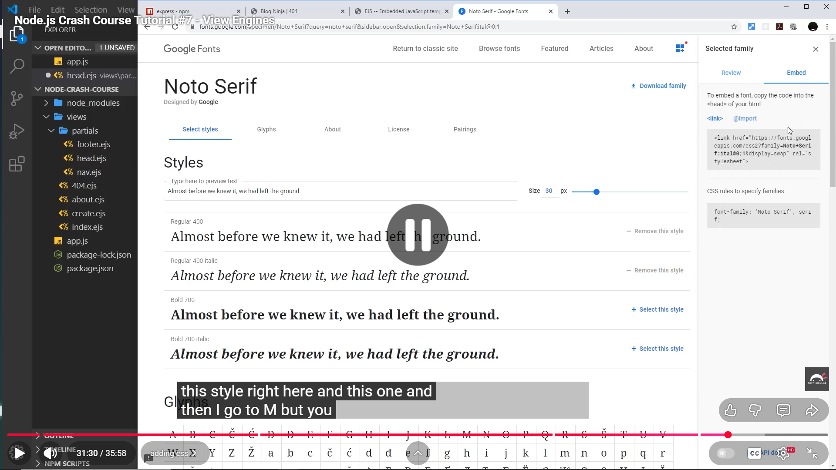

<https://youtu.be/_GJKAs7A0_4?si=ivUZAVvrFRepTGrp>

**Node.js Crash Course Tutorial #8 - Middleware**

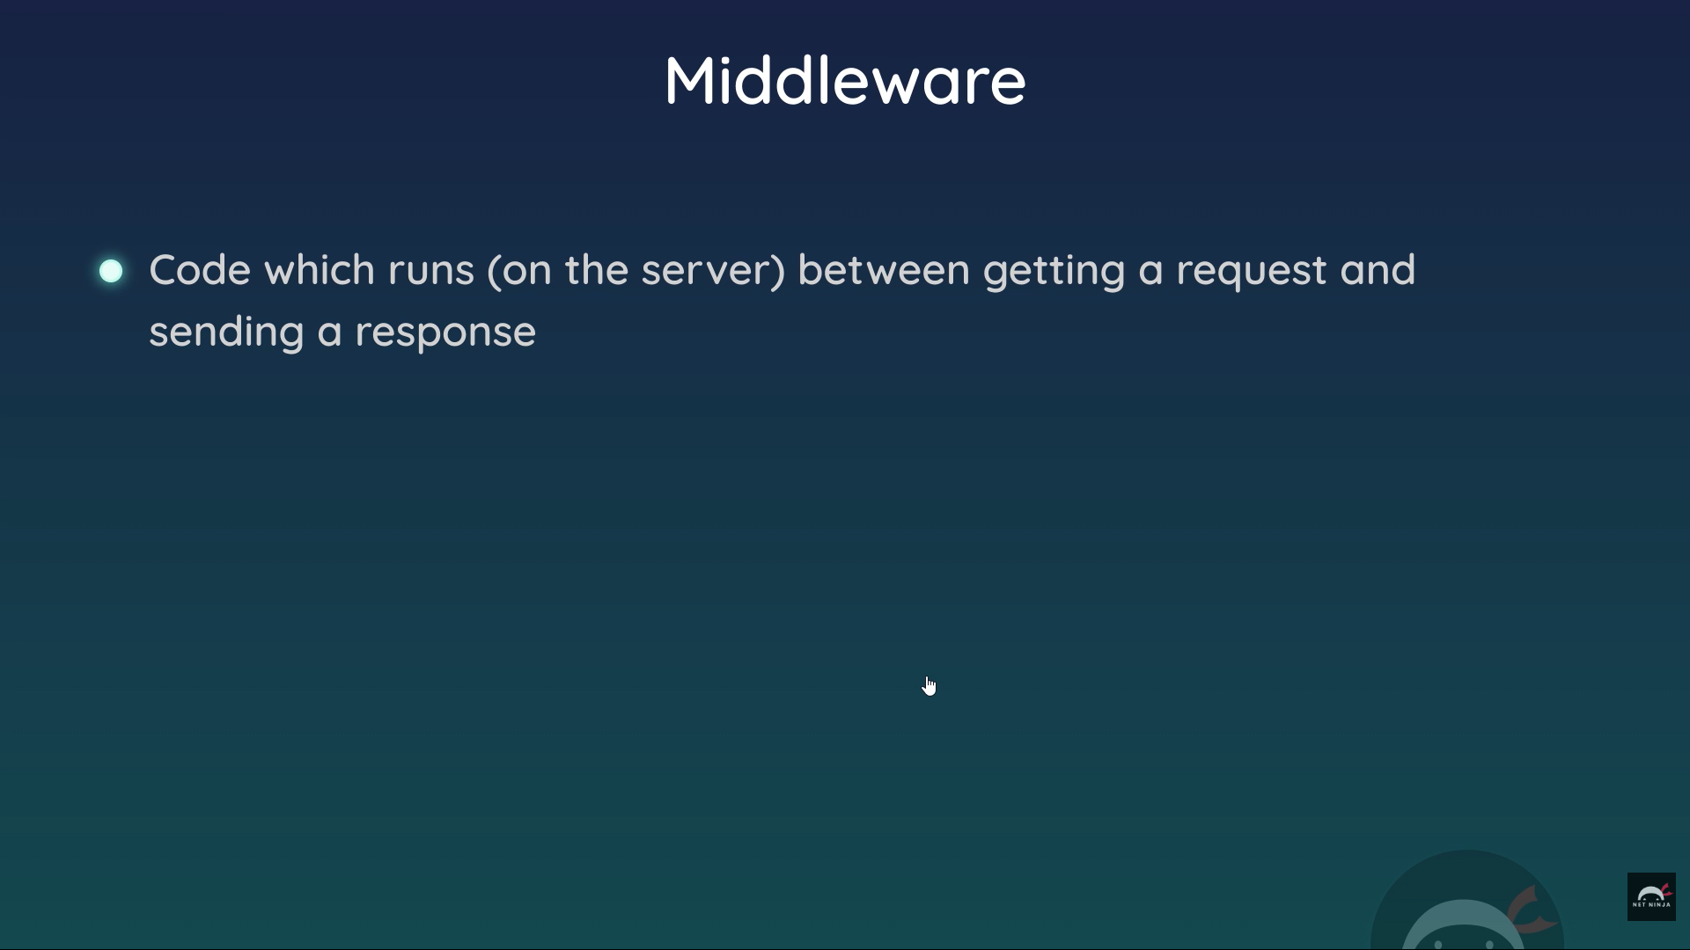

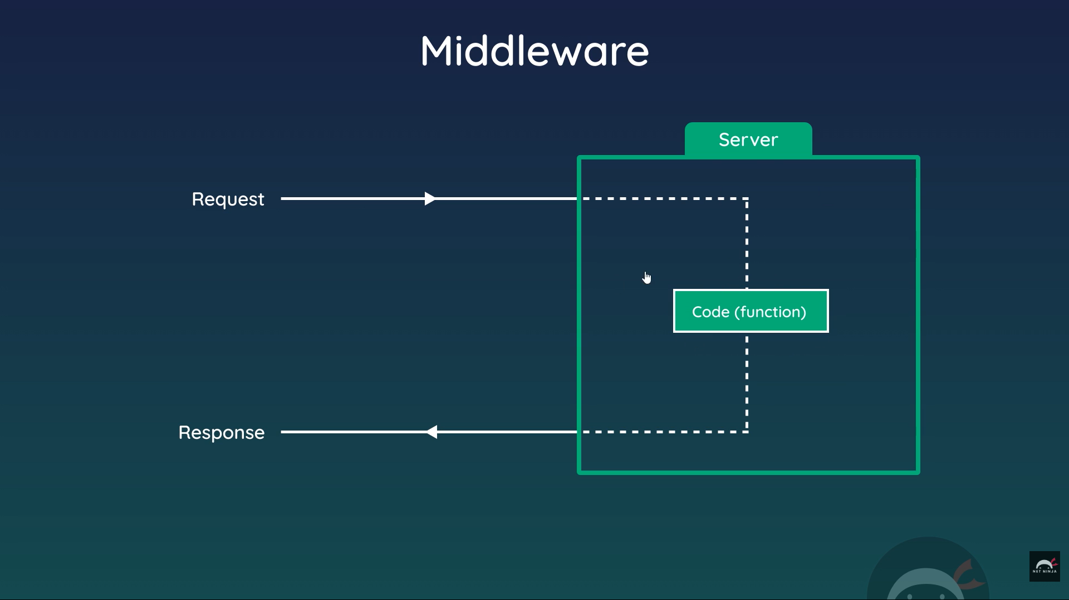

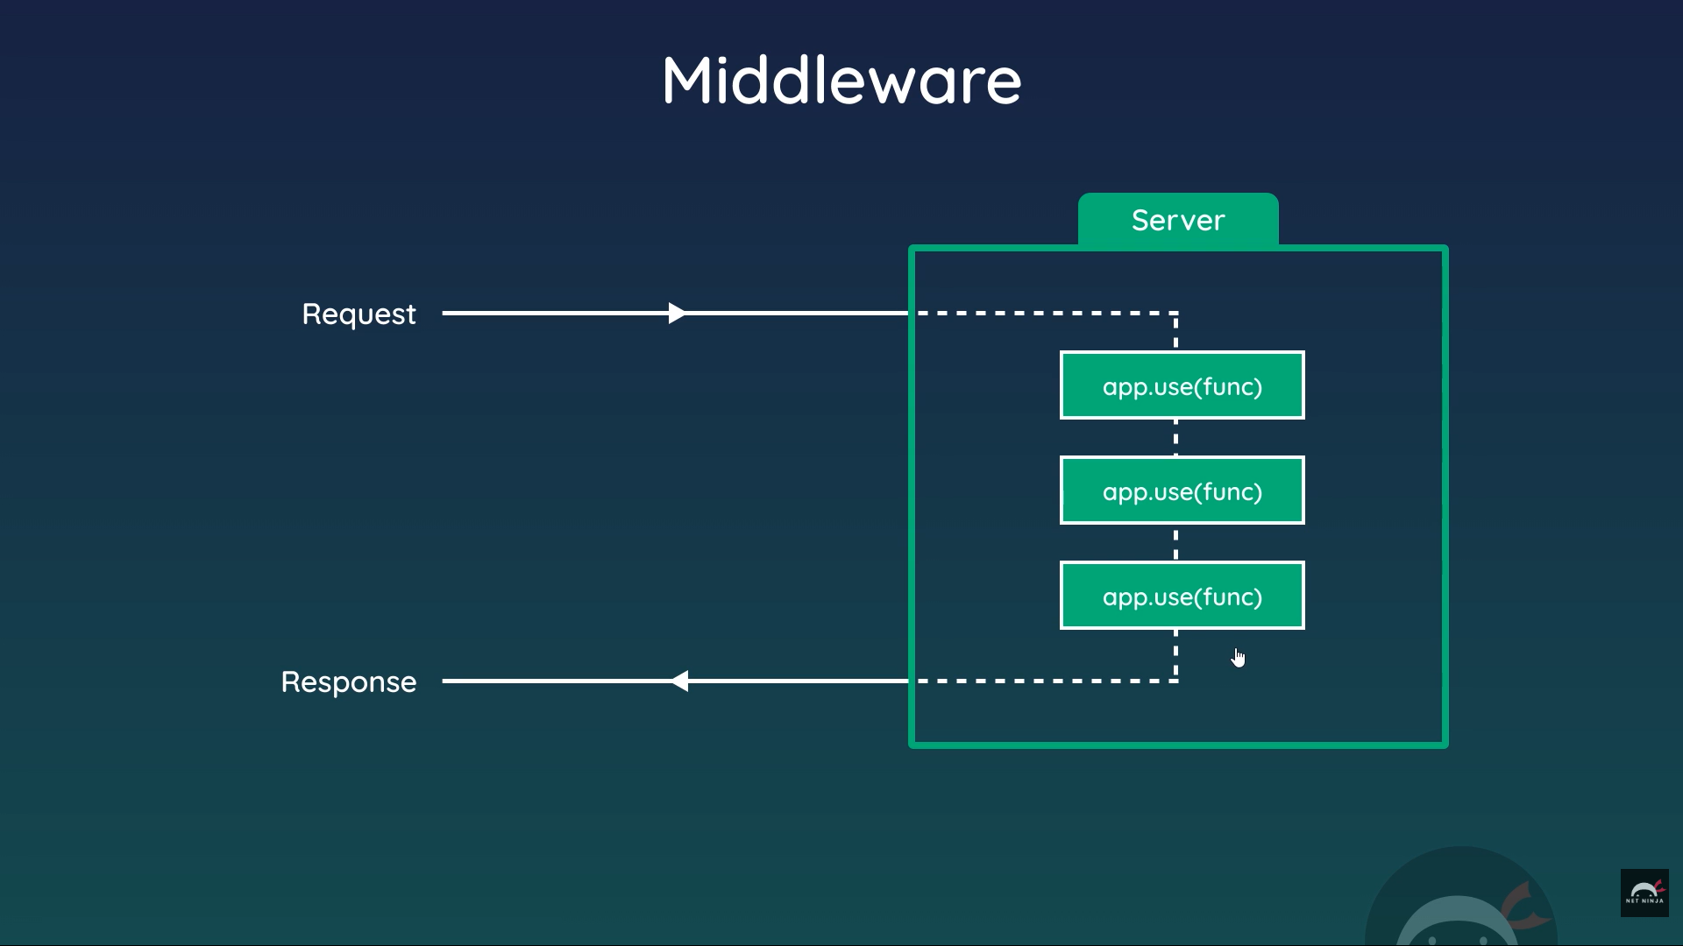

I started but nees to start from beginning

<https://youtu.be/_GJKAs7A0_4?si=C_Zb_nIXdnZ7MEV5>

stop : 22-12-2025(0715AM)

(85M)

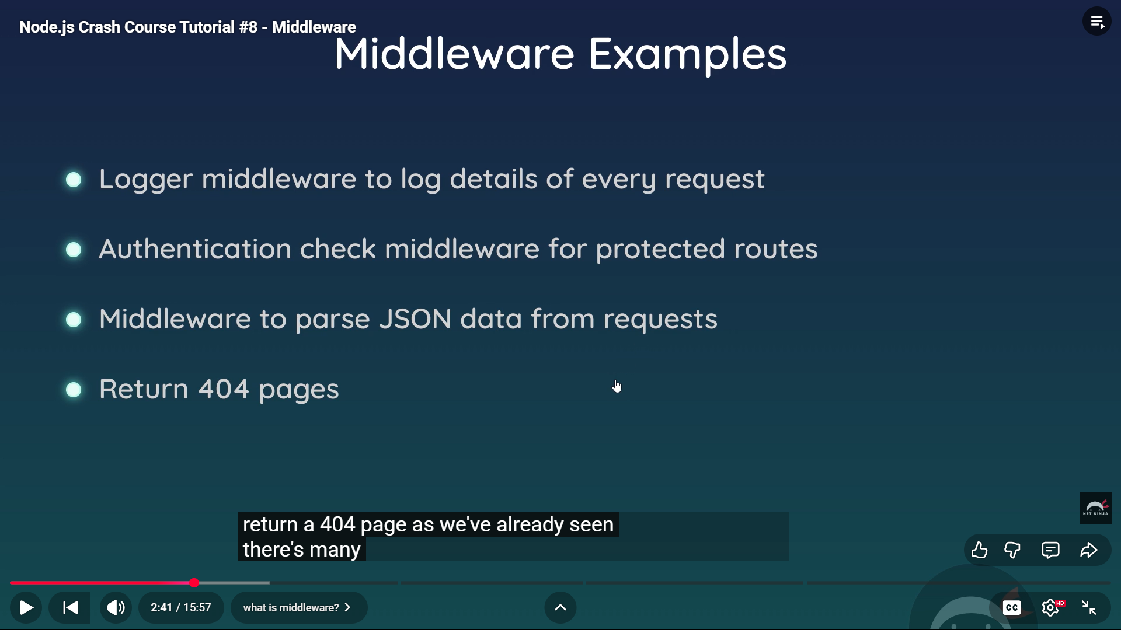

Start : 23Dec2025 06:00 AM

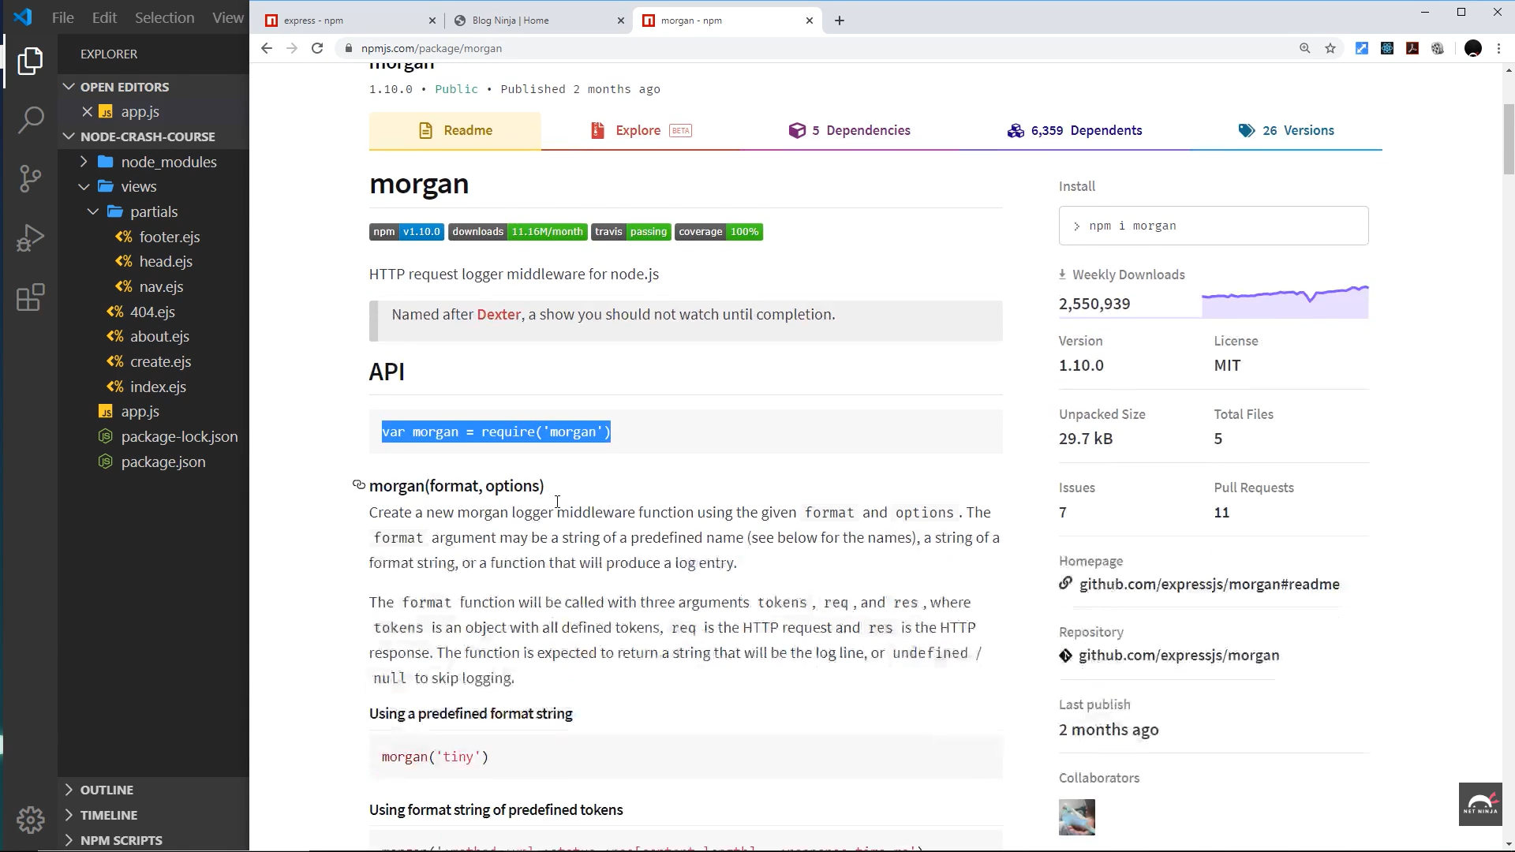

<https://youtu.be/bxsemcrY4gQ?si=az0FlOwnZT0kyakj>

**Node.js Crash Course Tutorial #9 - MongoDB**

mongodb.com/cloud/atlas

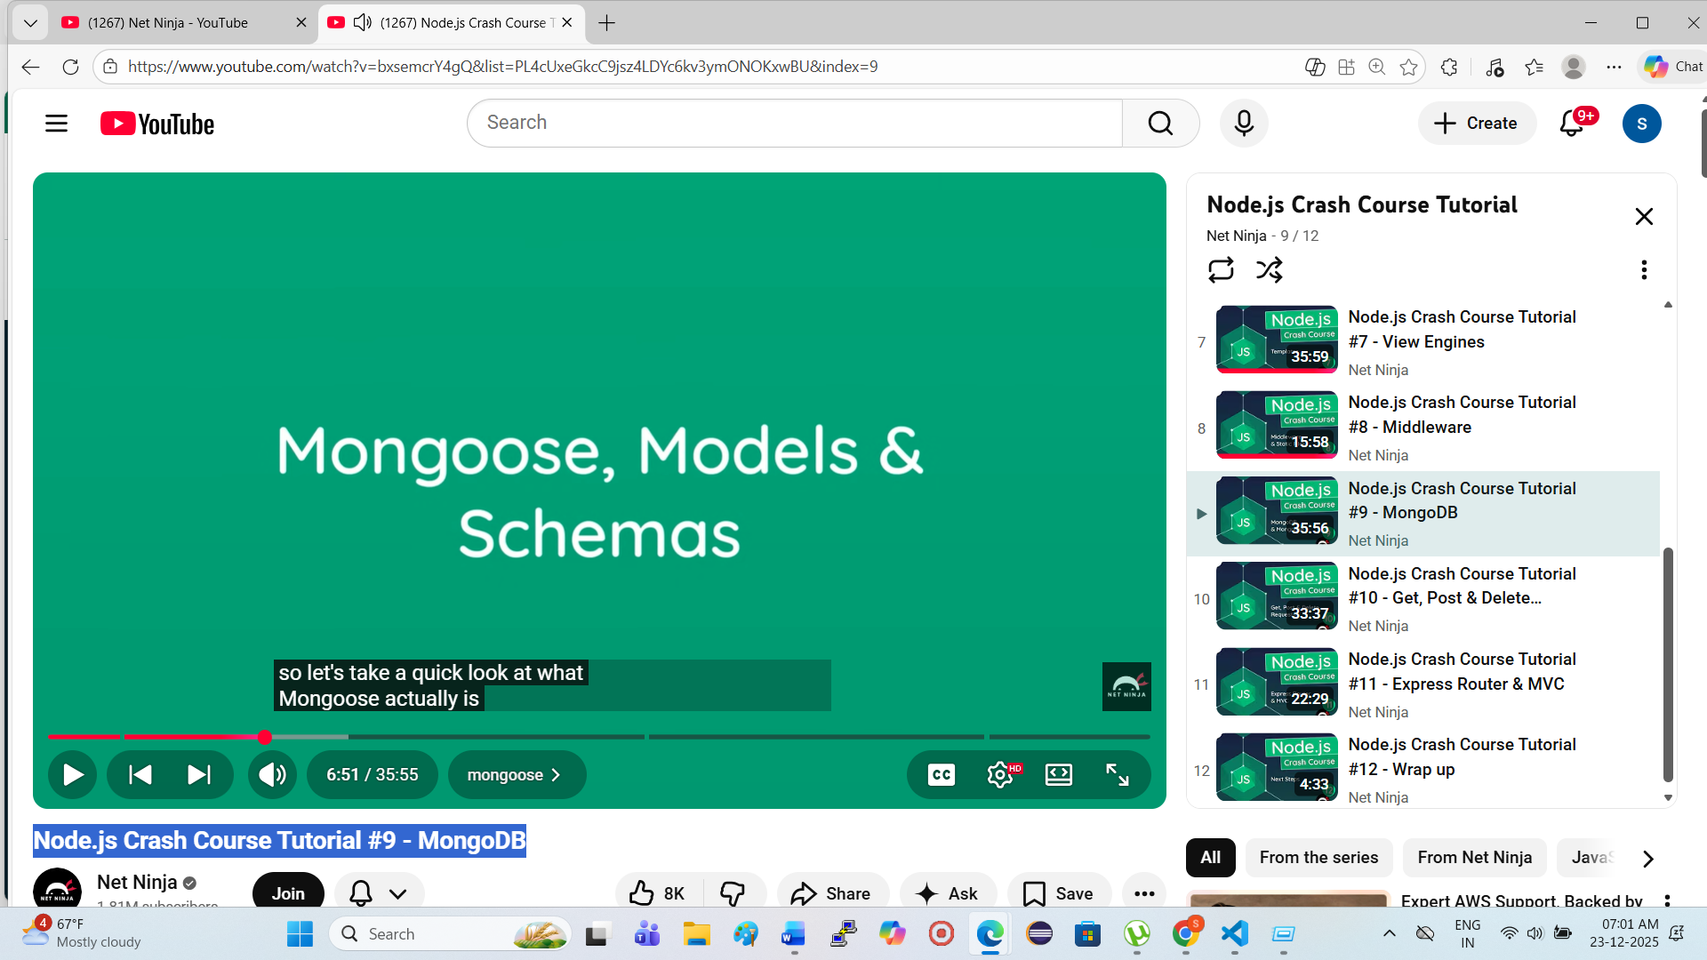

Stop : 07:00 AM 23-12-2025

St: 06:51

Note : Next u will start from 0651, then revise u will do the practical

Start: 24-12-2025 ,0550 AM

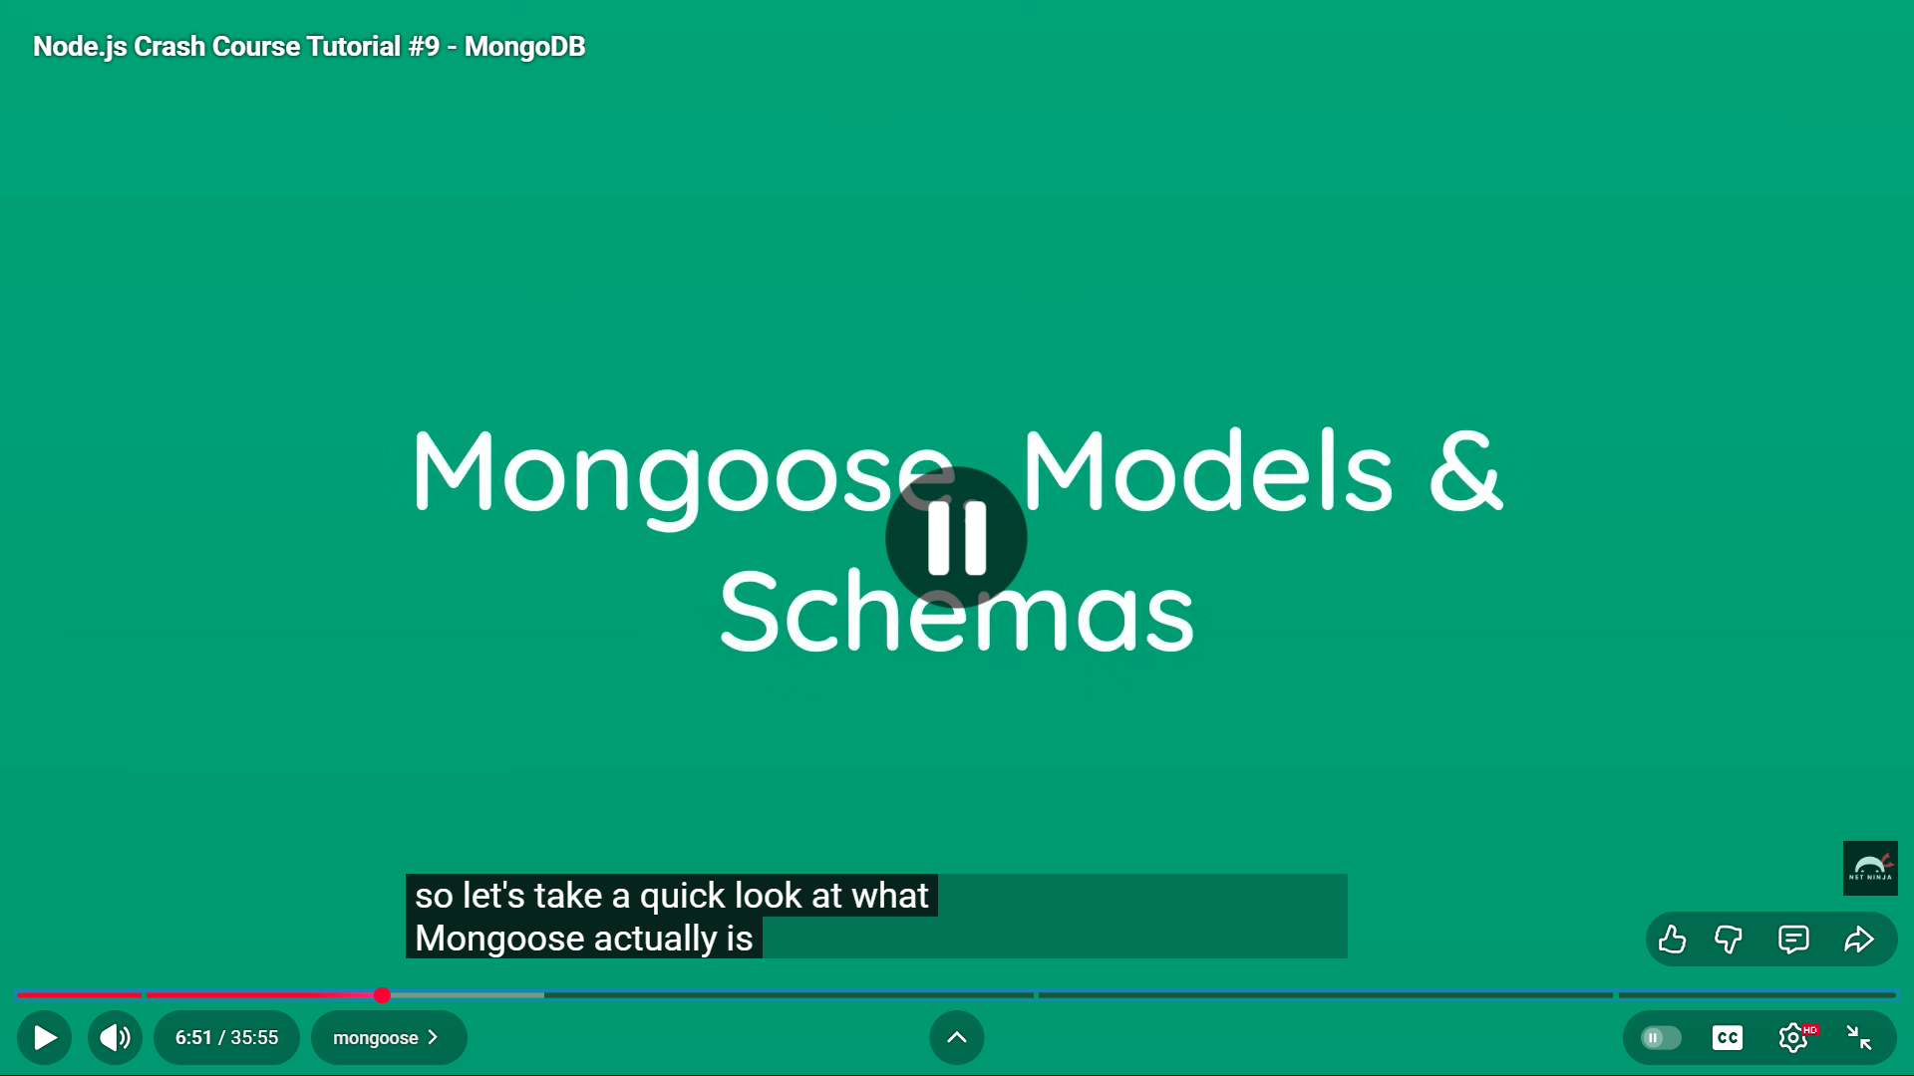

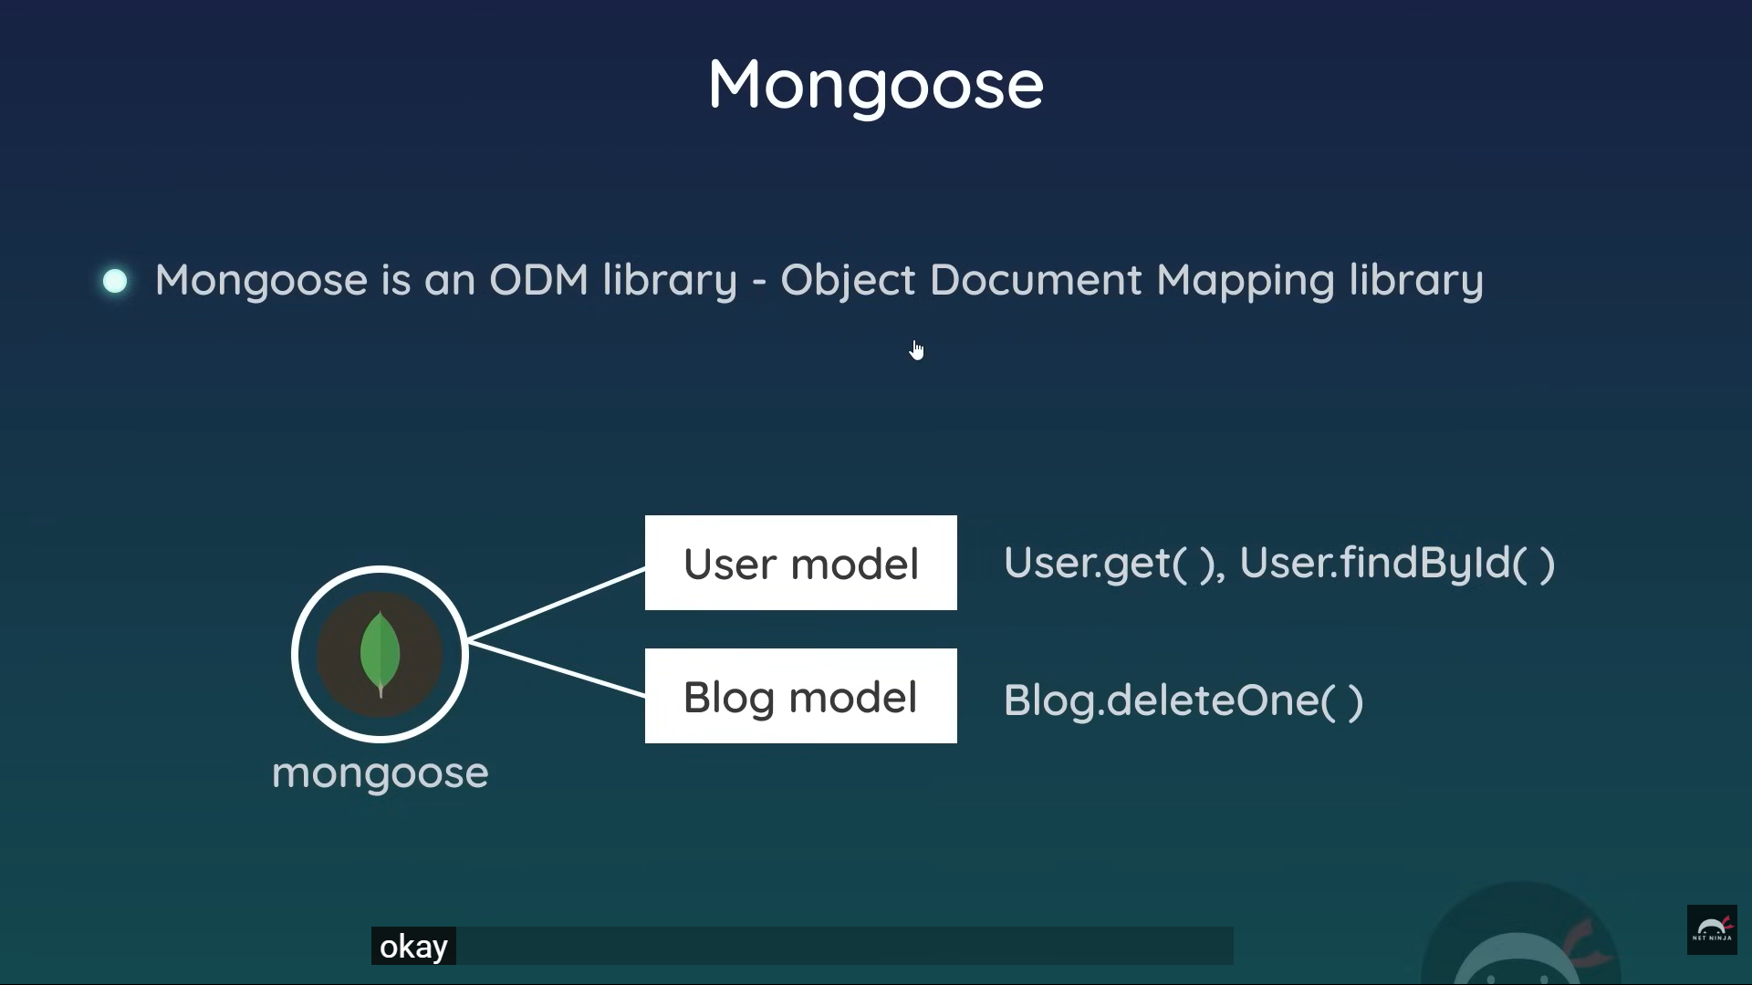

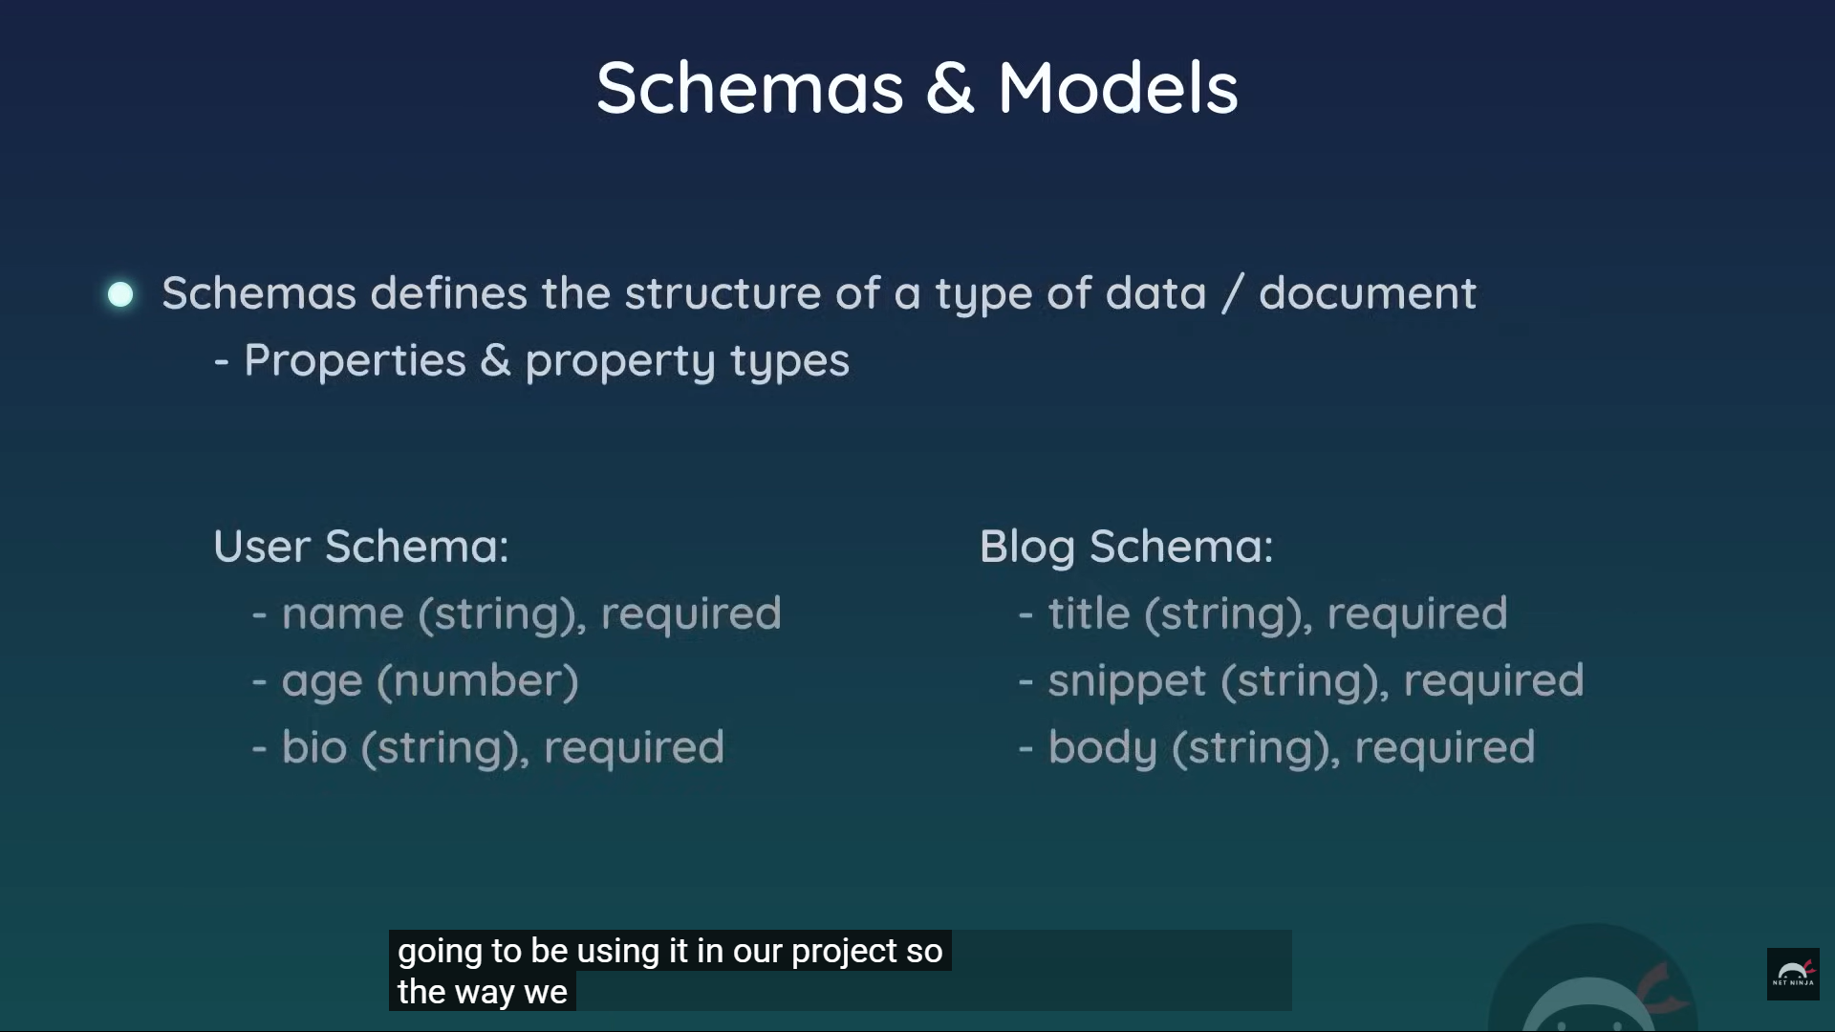

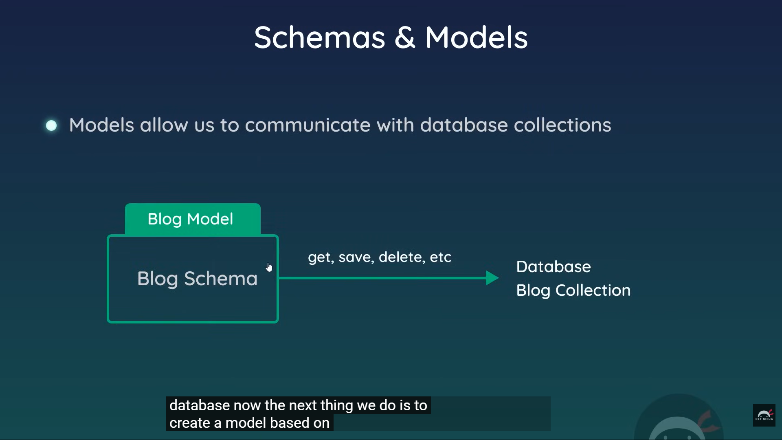

**Done at 0650 AM (60M)**

**Need to start revision**

**Starts : 25-12-2025, 05:16 AM**

mongodb.com/cloud/atlas

mongodb.com/cloud/atlas

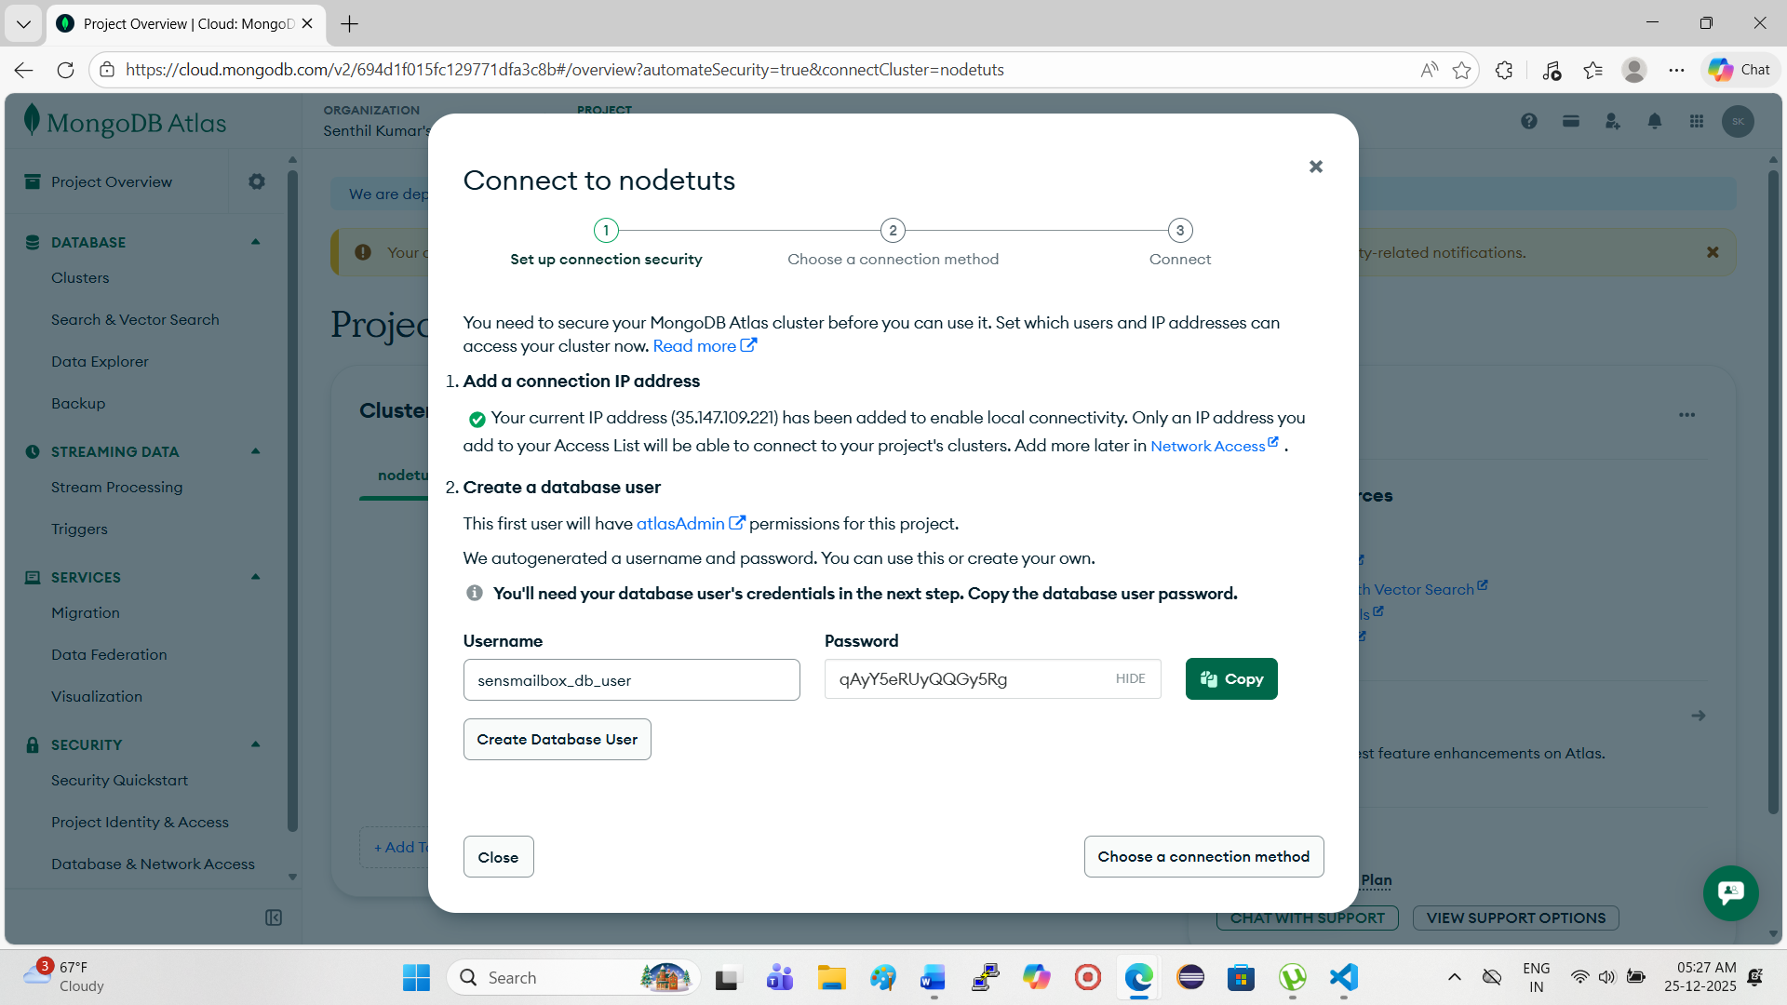

**mongodb+srv://netninja:<db_password>@nodetuts.tlmakya.mongodb.net/?appName=nodetuts**

**st : 20;36**